Task 1:
Mock Zomato Admin Panel Login Authentication

Objective: Implement a client-side authentication mechanism with hardcoded admin credentials to authenticate login attempts and grant access to the mock Zomato Admin Panel.

- Complete HTML & JavaScript Code (login.html):

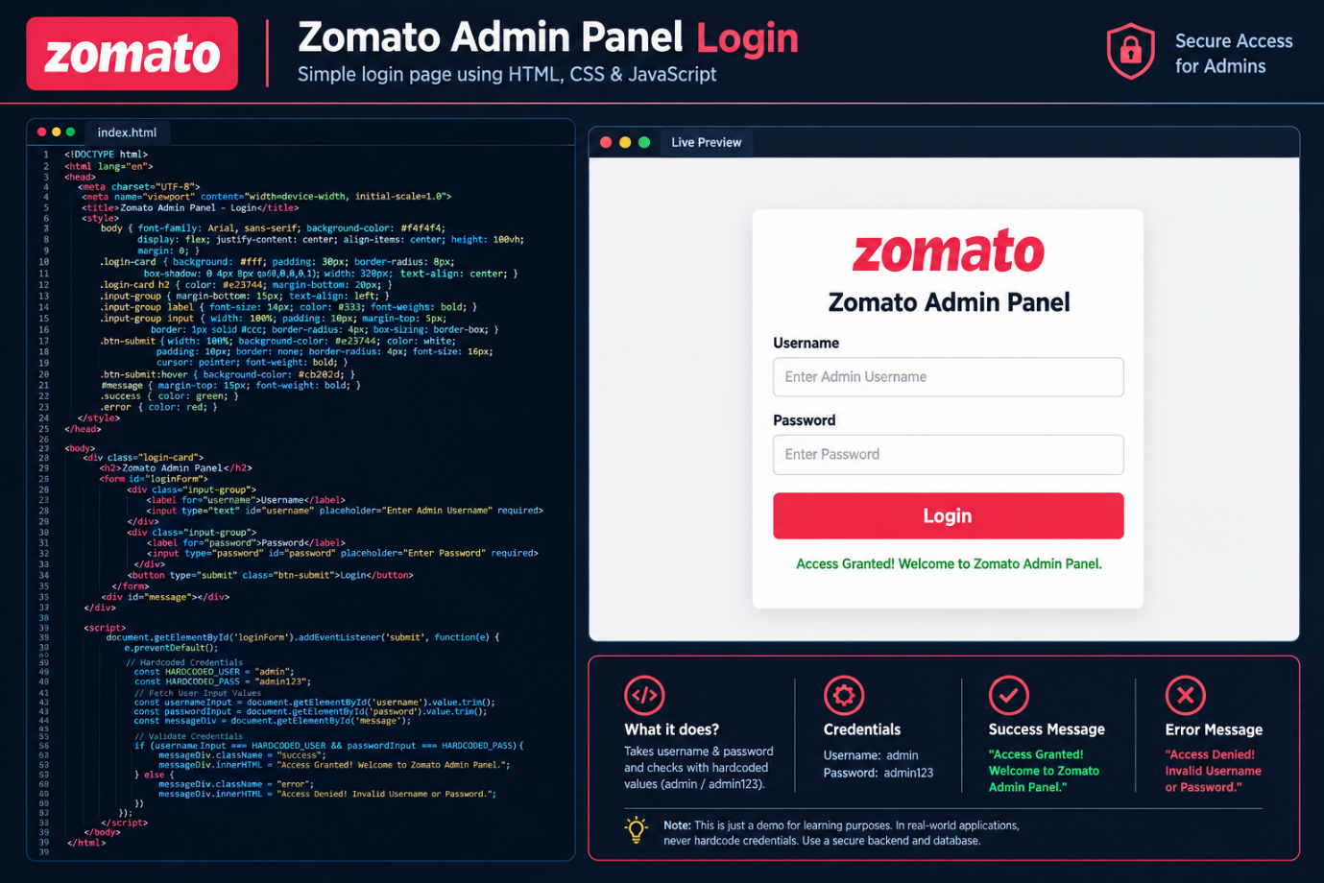

Input Username | Input Password | Expected Result | Actual System Behavior | Status
admin | admin123 | Access Granted | Displays "Access Granted! Welcome to Zomato Admin Panel." (Green Text) | PASSED
admin | wrongpass | Access Denied | Displays "Access Denied! Invalid Username or Password." (Red Text) | PASSED
user1 | admin123 | Access Denied | Displays "Access Denied! Invalid Username or Password." (Red Text) | PASSED

Task 2:
Role-Based Access Control (RBAC) System in Python

Objective: Develop a python-based Role-Based Access Control (RBAC) module utilizing dictionary lookup structures to authorize access to system resources based on assigned user roles.

1. Complete Python Source Code:
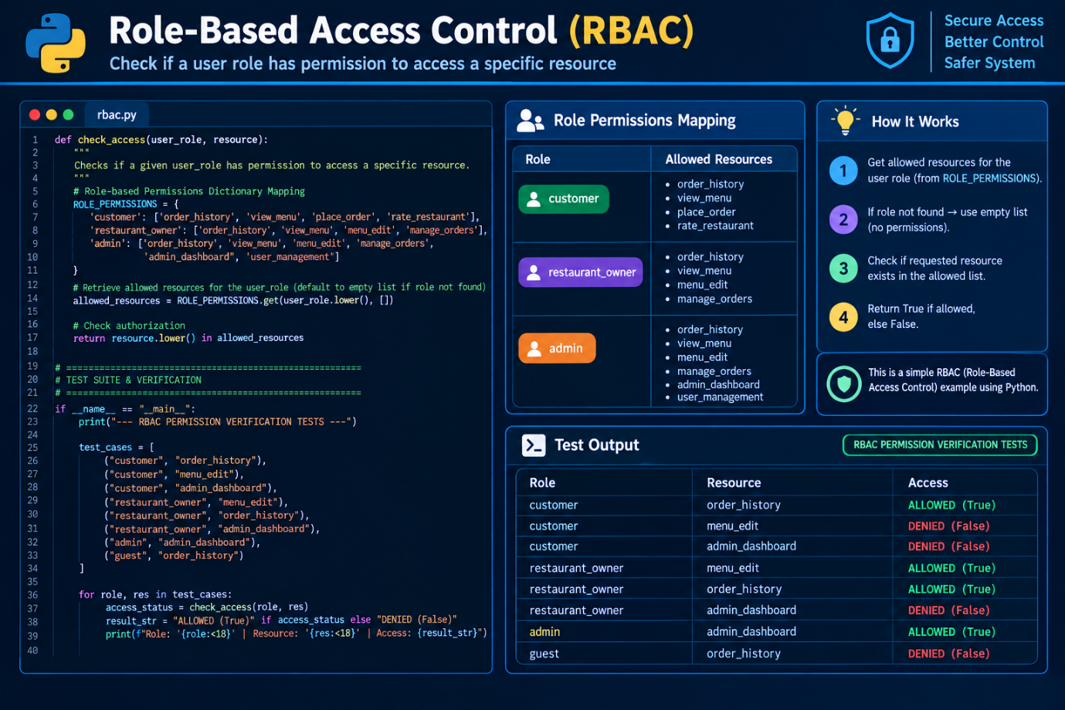

- Execution Output & Verification Matrix:

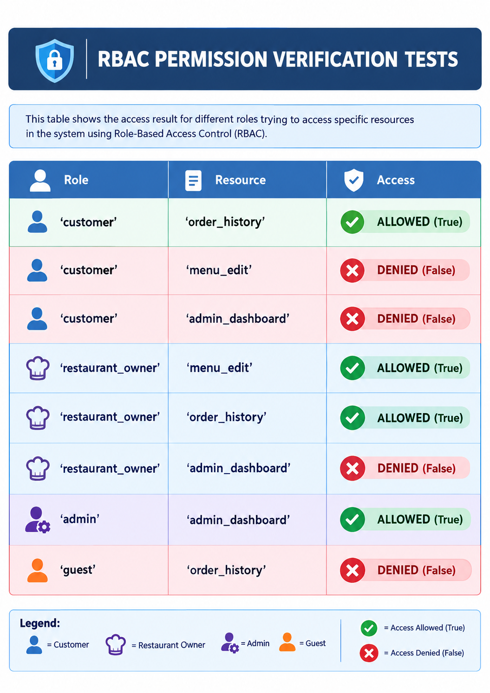

Task 3:
Paytm-Style Two-Factor Authentication (2FA) Flow Simulation

Objective: Implement a multi-step authentication process that combines knowledge-based factor (Password) with an out-of-band dynamic factor (6-digit dynamic OTP) to authorize user logins.

1. Complete Python Source Code:
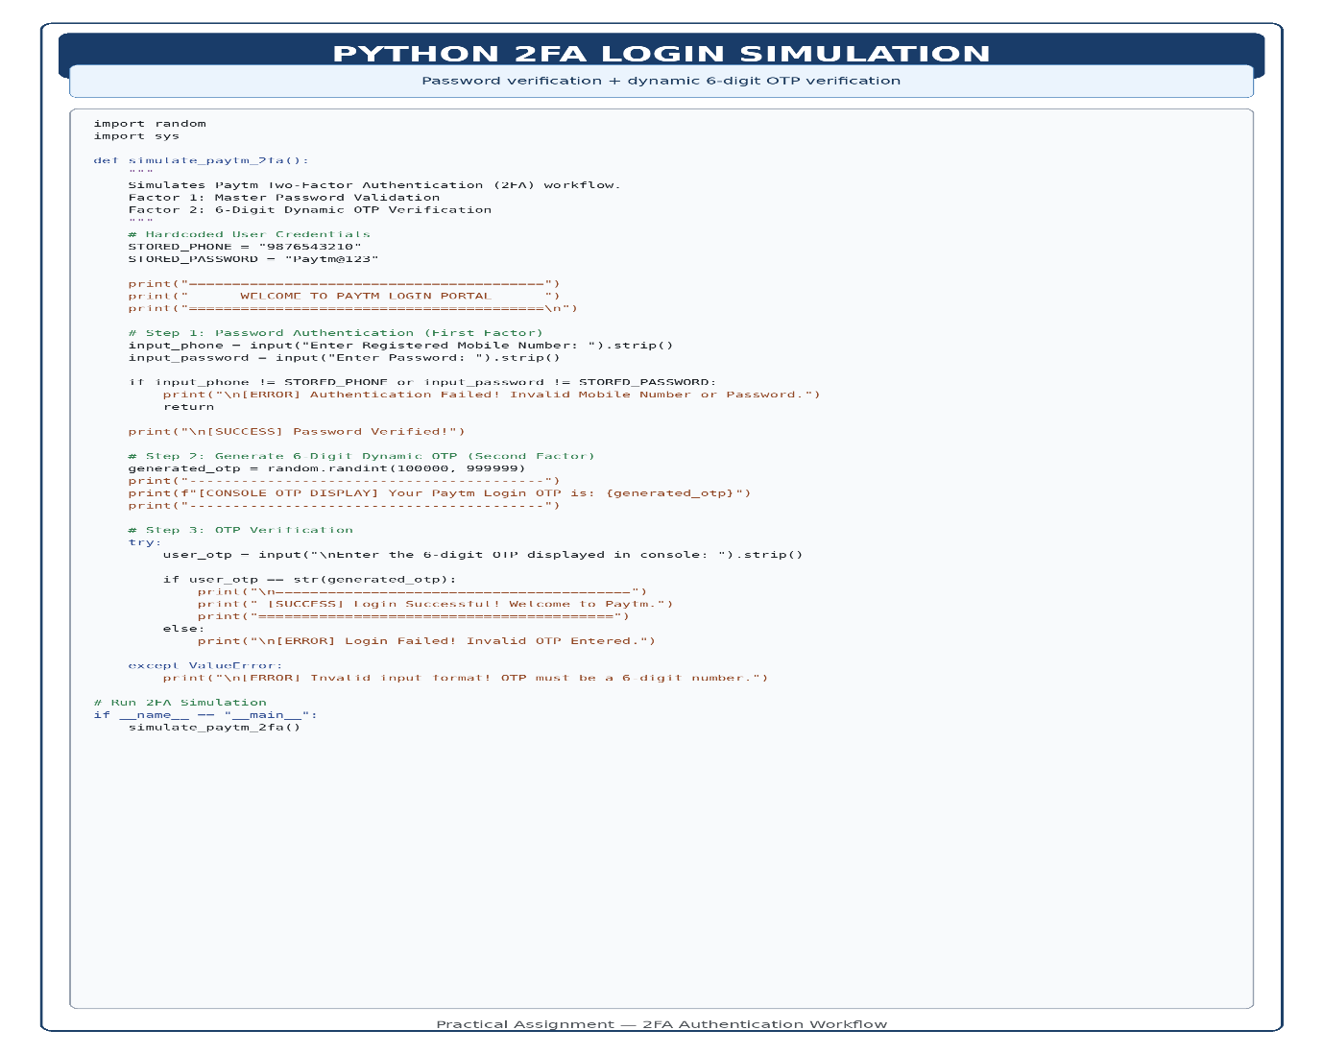

2. Execution Flow & Console Logs:
Successful Login Case (Correct Password + Correct OTP):

=========================================
WELCOME TO PAYTM LOGIN PORTAL
=========================================

Enter Registered Mobile Number: 9876543210
Enter Password: Paytm@123

[SUCCESS] Password Verified!
-----------------------------------------
[CONSOLE OTP DISPLAY] Your Paytm Login OTP is: 582914
-----------------------------------------

Enter the 6-digit OTP displayed in console: 582914

=========================================
[SUCCESS] Login Successful! Welcome to Paytm.
=========================================
Failed Login Case (Wrong OTP Entered):

=========================================
WELCOME TO PAYTM LOGIN PORTAL
=========================================

Enter Registered Mobile Number: 9876543210
Enter Password: Paytm@123

[SUCCESS] Password Verified!
-----------------------------------------
[CONSOLE OTP DISPLAY] Your Paytm Login OTP is: 931047
-----------------------------------------

Enter the 6-digit OTP displayed in console: 123456

[ERROR] Login Failed! Invalid OTP Entered.

Task 4:
Active Premium User Filter Function (Date-Based Filtering)

Objective: Implement a date-parsing and conditional filtering function in JavaScript and Python to identify active premium subscribers who have logged in within a 7-day window relative to a fixed baseline date (2024-06-10).

1. JavaScript Implementation Code:

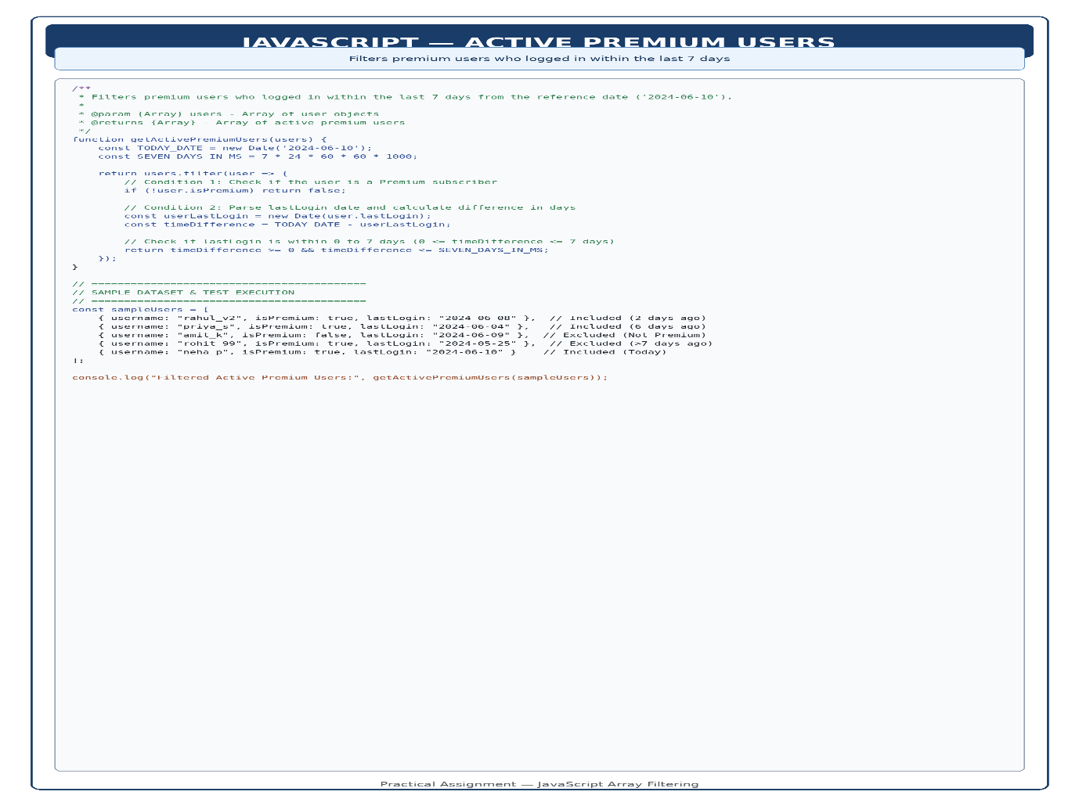
2. Python Implementation Code (Alternative):

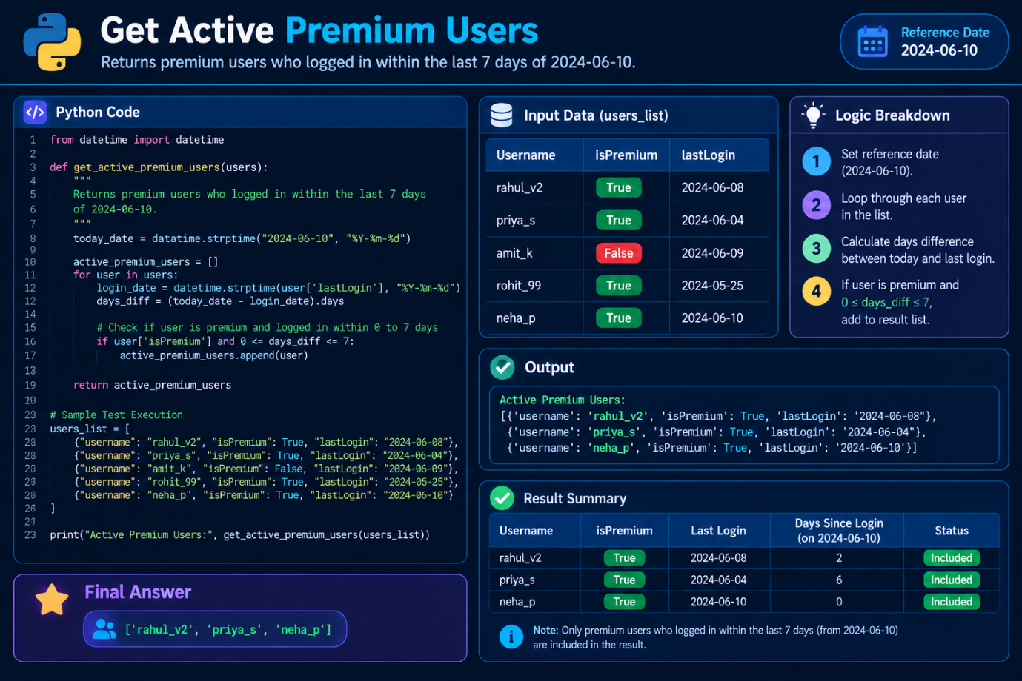

- Execution Test Results Table:
Username | isPremium Status | lastLogin Date | Days Difference from 2024-06-10 | Filter Result | Reason
rahul_v2 | true | 2024-06-08 | 2 Days | INCLUDED | Premium user & logged in within 7-day window.
priya_s | true | 2024-06-04 | 6 Days | INCLUDED | Premium user & logged in within 7-day window.
amit_k | false | 2024-06-09 | 1 Day | EXCLUDED | Failed isPremium condition (false).
rohit_99 | true | 2024-05-25 | 16 Days | EXCLUDED | Exceeded 7-day threshold (> 7 days).
neha_p | true | 2024-06-10 | 0 Days | INCLUDED | Premium user & logged in today.

Task 5:
5 Common Access Control Vulnerabilities & Prevention Fixes

Objective: Document 5 critical access control flaws commonly introduced during full-stack web and mobile application development (e.g., Instagram, Flipkart) alongside concise, single-line mitigation strategies for each vulnerability.

